Department of Computer Science and Engineering

BRAC University

CSE 260: Digital Logic Design

Experiment # 4

Parity Generator and Checker

Objective:

- To design and implement an Even parity Generator and Even parity checker using XOR gates) (IC-7486).

Required Components and Equipments

- AT-700 Portable Analog/Digital Laboratory
- 7400×3
Diagram of Circuit:

Even Parity generator
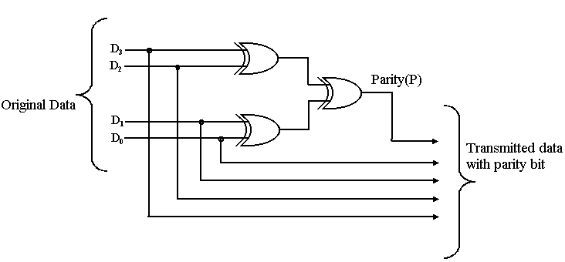
Even Parity Checker
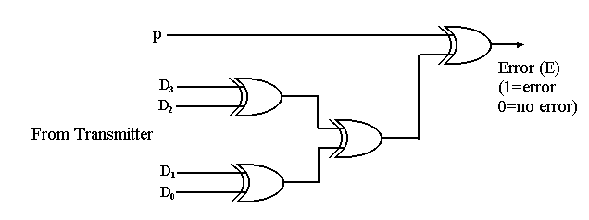

Procedure:

- Construct the Circuit of Figure 1, on the breadboard of AT-700.
- Remember each IC’s pin 14 connected to “+5V” position of DC Power Supply of AT-700, and pin 7 connected to “GND” position.
- Connect the inputs to Data switches and outputs to any position of LED Display.
- Determine the parity generator’s output for each of the following sets of input data, D₃D₂D₁D₀; (a) 0111; (b) 1001; (c) 0000; (d) 0100
- Determine the parity checker’s output for each of the following sets of data from the transmitter
P D₃ D₂ D₁ D₀
_________________________
0 1 0 1 0
1 1 1 1 0
1 1 1 1 1
1 0 0 0 0

Report:
The report should cover the followings

- Name of the Experiment
- Objective
- Required Components and Equipments
- Experimental Setup (You must draw the IC configurations)
- Results in Tabulated form.
- Discussions (Explanation of the results)

